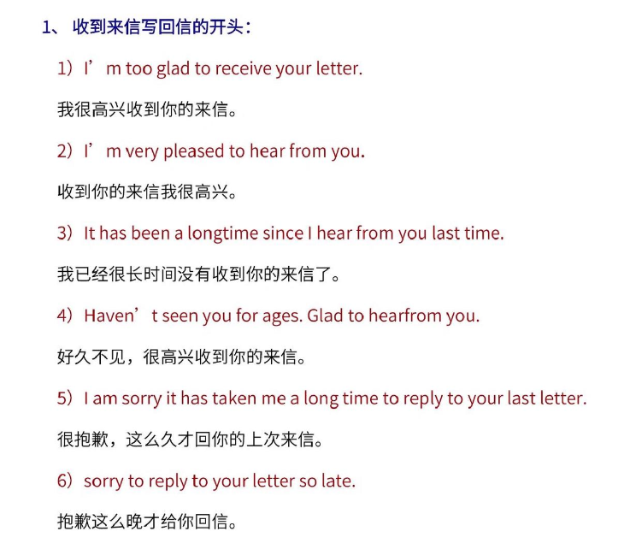
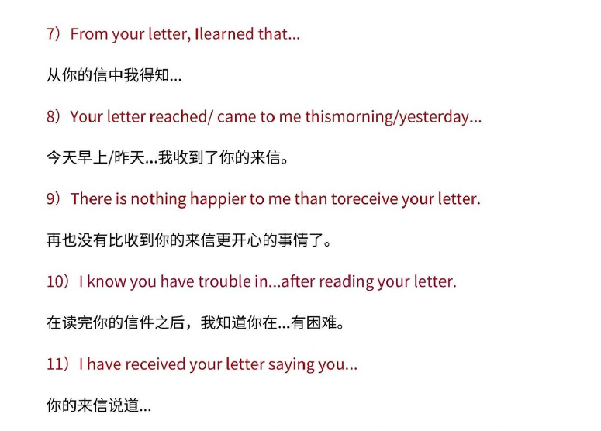
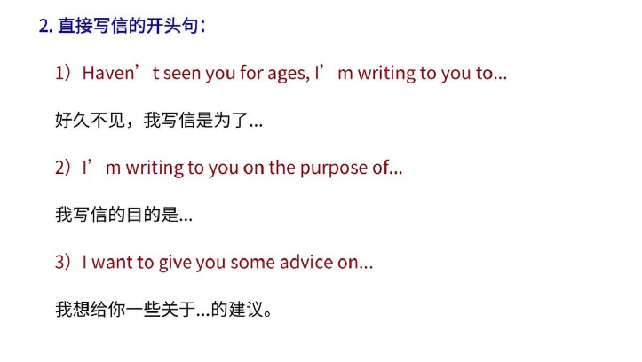
Recently I heard that you… ,so I would like to give you some proposal
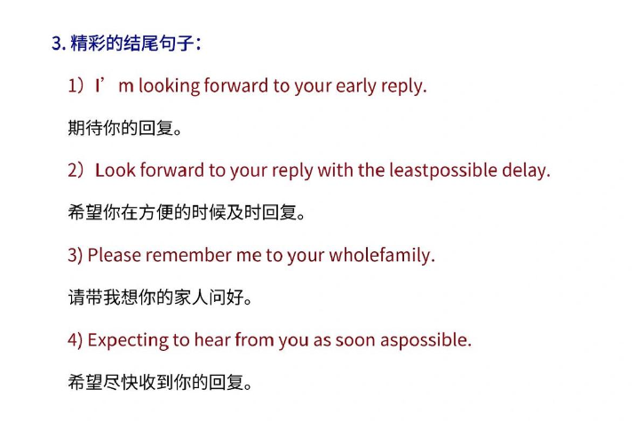
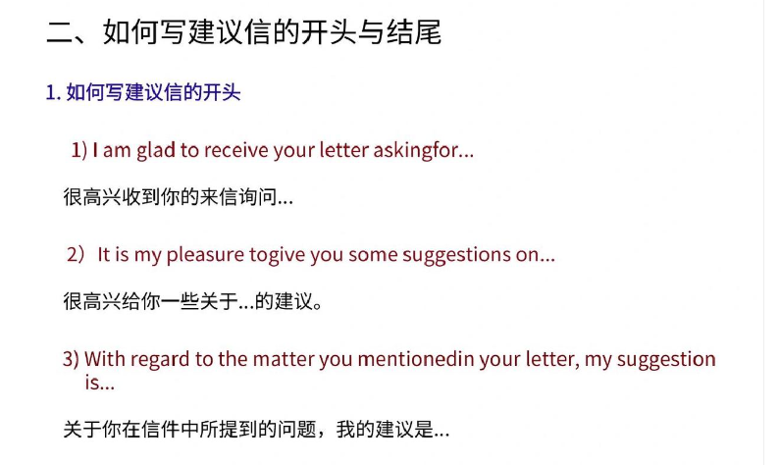
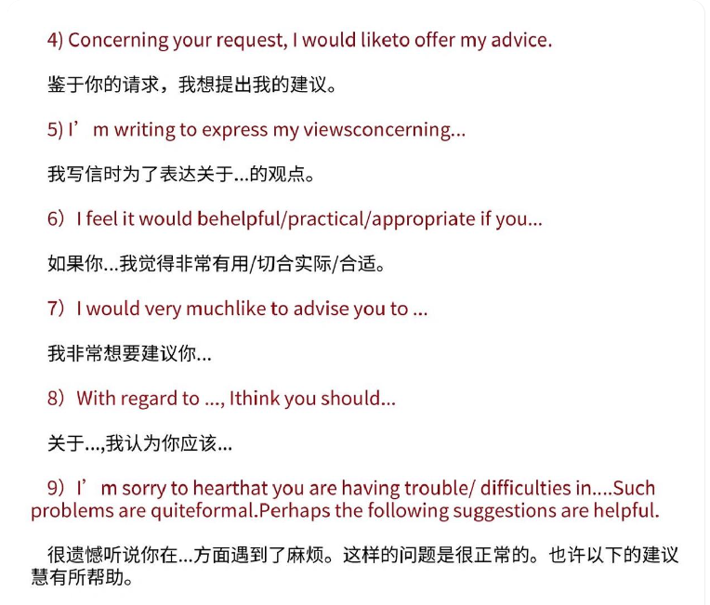
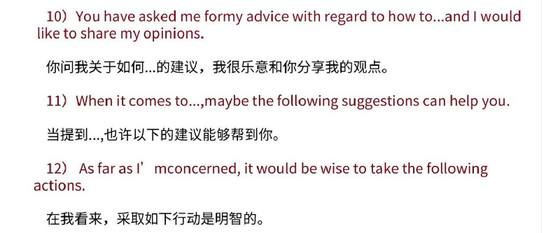
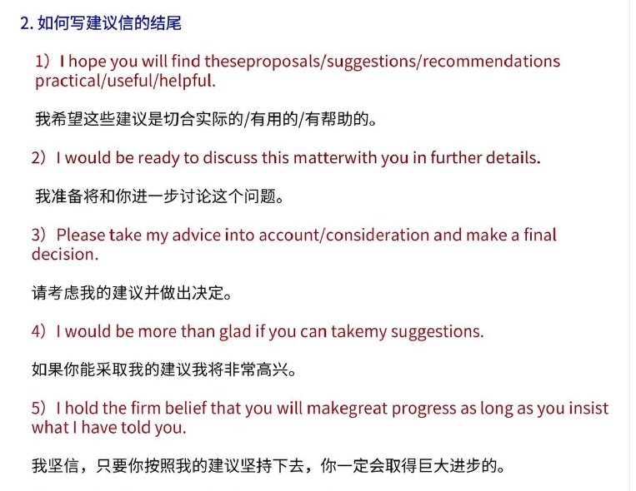
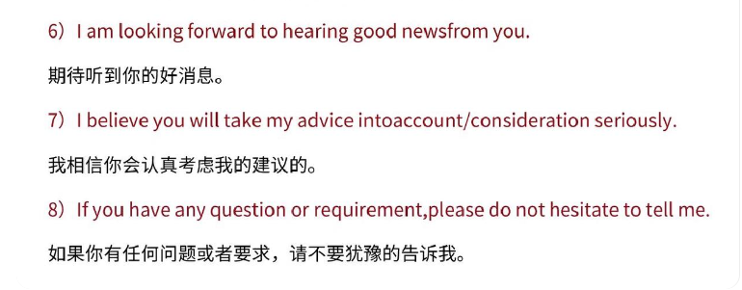
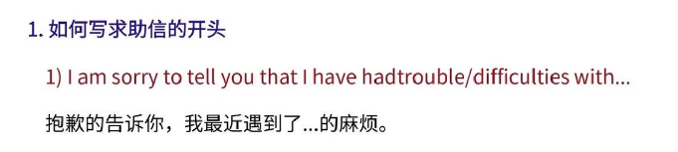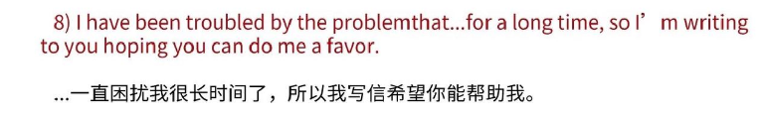
I've heard lately that you're having trouble with something 最近听说你在某方面遇到了麻烦
Good->fantastic
Facilitate your study career
Coincidentally, I have had similar experiences.
Here is my suggestions
Considerable
It perfectly fits with what I said above
mentioned before 之前提到的
It's just as important as what I said above它和我上面所说的同等重要
Do something for practice
Interesting things will happen here
The second place I recommend is
The third considerable place is
be located in 坐落于
The matter deserves your attention 这件事值得你注意
in a nutshell 总而言之
In addition ；besides；beyond that +sth 除此之外
make somebody do something
（Intercultural）Cultural exchange center 文化交流中心
通过：through ；through communication
Identify the problem and then make corrections 发现问题然后改正
personal experience 切身体会 n
personally experience grand culture
efficient
heavy work
Form a circle
Seat around the campfire 坐在篝火旁
Staring at the sky with the brilliant stars 凝视着有灿烂星星的天空
Expertly cooperate熟练配合
price代价

